
Secondary Transfer 2027
Applying for a School Place

www.eadmissions.org.uk

www.barnet.gov.uk/schooladmissions


Who is this for?
Children born between 1 September 2015 and 31 August 2016 are due to transfer from primary to a secondary school in September 2027. If your child is due to transfer to a secondary school in September 2027, you should apply for a place online.

Before you start
Choosing a school
You need to decide which schools you want to apply to
To help you do this, visit www.barnet.gov.uk/schooladmissions
- download A guide to Secondary Education in Barnet 2027;
- attend the school open evenings and open days;
- talk to your child and find out what they want;
- do your research - look at the information published on school websites and school prospectuses;
- consider how your child will travel to and from school - walking, cycling or public transport options;
- check the admissions criteria to see if your child is likely to be offered a place and look at how places were allocated in previous years;
- consider including a mix of school preferences, as most schools receive more applications than there are places available;

- talk to others but make your own choices; your child is unique;
How to apply
- apply online at www.eadmissions.org.uk
(check your home Local Authority’s website for information on how to apply, if you live outside London);
- you can register your mobile phone number to receive reminder alerts;
- you can apply for up to six schools, in Barnet or elsewhere;
- it is important to list schools in the order you prefer them;
- attach relevant supporting documents to your application;
- some schools, usually faith schools, will also require you to complete a Supplementary Information Form – this should be returned directly to the school;
- the closing date for applications is 31 October 2026.

What happens next?
- Your home Local Authority will let other local authorities know about any applications you have made for schools in their area;
- schools will use their admissions criteria to list children in the order of priority for a place;
- your school preference order is not passed to schools;
- if more than one place can be offered, you will be offered a place at the school you ranked higher in your order of preference;
- all lower preferences will be withdrawn;
- no child will be offered more than one place;
- your child will stay on the waiting lists for schools you ranked higher than the one you have been offered;
- if it is not possible to offer you one of your preferences, we will allocate a place at an alternative school;
- you will receive an email on the evening of National Offer Day, 1 March 2027;
- click on the ‘Reply’ button at the bottom of the email and log in to your
eAdmissions account to accept or decline your offer;

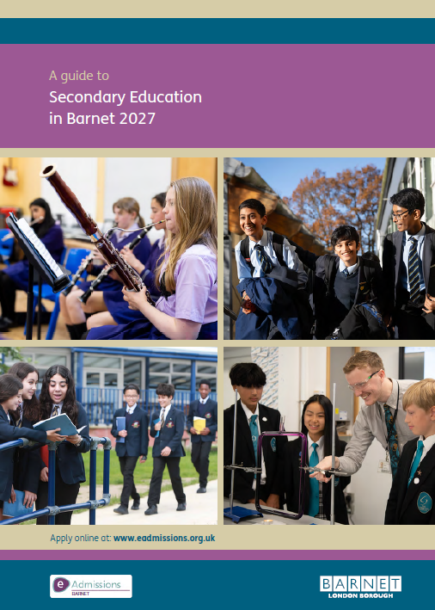

- you must respond to your offer by 15 March 2027.

Visiting schools
- Most schools are planning to hold the traditional face-to-face open evenings;
- A schedule of open evenings is available from your child's primary school and is also published in the guide Secondary Education in Barnet 2027 (please check individual school websites for latest information).

Further support and advice
Help completing the application form:
Choose ‘Help & Tutorials’ from your eAdmissions Home Page
Help with anything else:
Online: www.barnet.gov.uk/schooladmissions
Tel: 020 8359 7651

